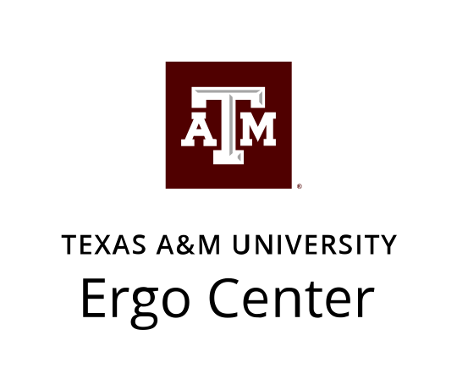

DATE: 7 September 2021
MEMORANDUM
TO: Stephen Arnold, Raelynn Mitchell
FROM: Martha Parker
RE: NIOSH Training Grant Awardees for “press release” and item for the Ergo Center website

The Texas A&M Ergo Center would like to congratulate the latest recipients of the NIOSH Training Grant. Each student receives a monthly stipend as well as paid tuition and program related travel assistance. Every one of these students was a highly competitive applicant for the traineeships and will be required to meet rigorous standards in order to maintain their award. Affectionately known as “NIOSH kids”, the Ergo Center is very proud of these six students and is expecting great things from them!
Austin Akin: I am an MPH student in Occupational Safety & Health. I am looking forward to serving as an EHS professional upon graduation. I obtained my undergraduate degree from Texas A&M and have worked with the University's Department of Recreational Sports most of my time at A&M.
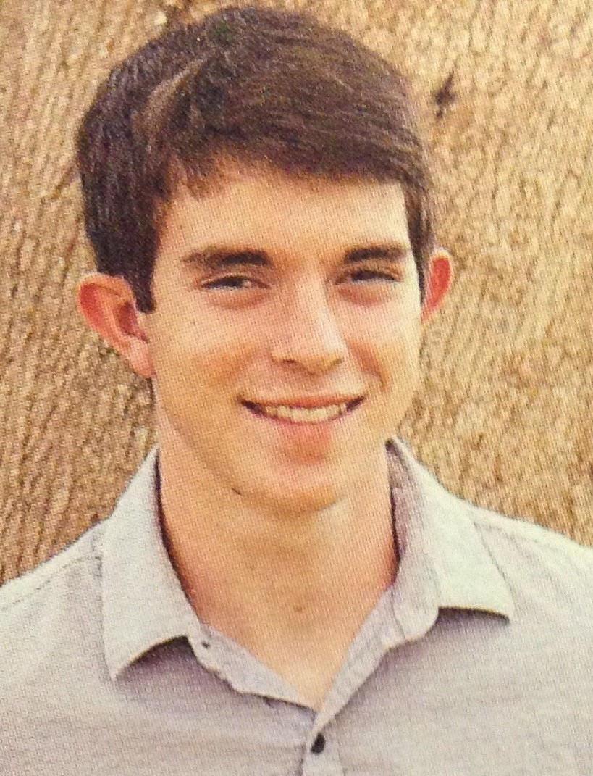

Jessica Barajas: I am a Master of Public Health student at Texas A&M University with a concentration in Occupational Health and Safety. My previous occupational health & safety experiences are in semiconductor fabrication and construction. I hope to work in either of those industries upon graduation. Currently, I live in College Station and have two bunnies named Eevee and Peep.
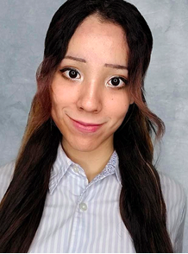

Jacob Birenbaum; I am an MPH student studying Occupational Safety and Health along with a Certificate in Business. After graduating in August 2022, I plan to work as an Environmental Health and Safety professional with specific interests in industrial hygiene and risk management. I have a one-year-old Pomeranian puppy named George, and I have traveled to 9 Texas Aggie away football games over my time at Texas A&M.
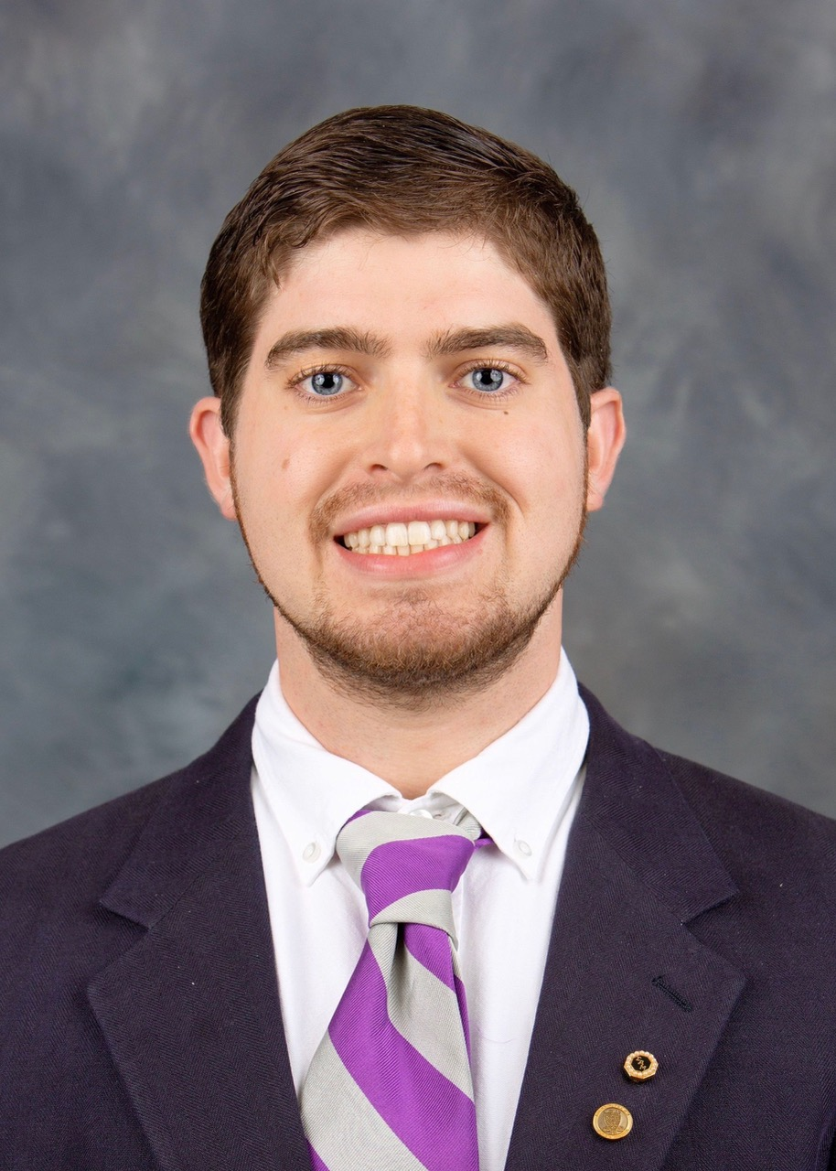

McKenna Schutty: I am an MPH student in Occupational Health and Safety. My goal is to become a safety manager or director of a great company upon graduation. I earned my undergrad degree in public health here at Texas A&M, and I'm so lucky to come back! In my free time, my sister and I love to travel, and this year we have been to Belize and are currently planning a trip to Napa Valley and Chicago in December!
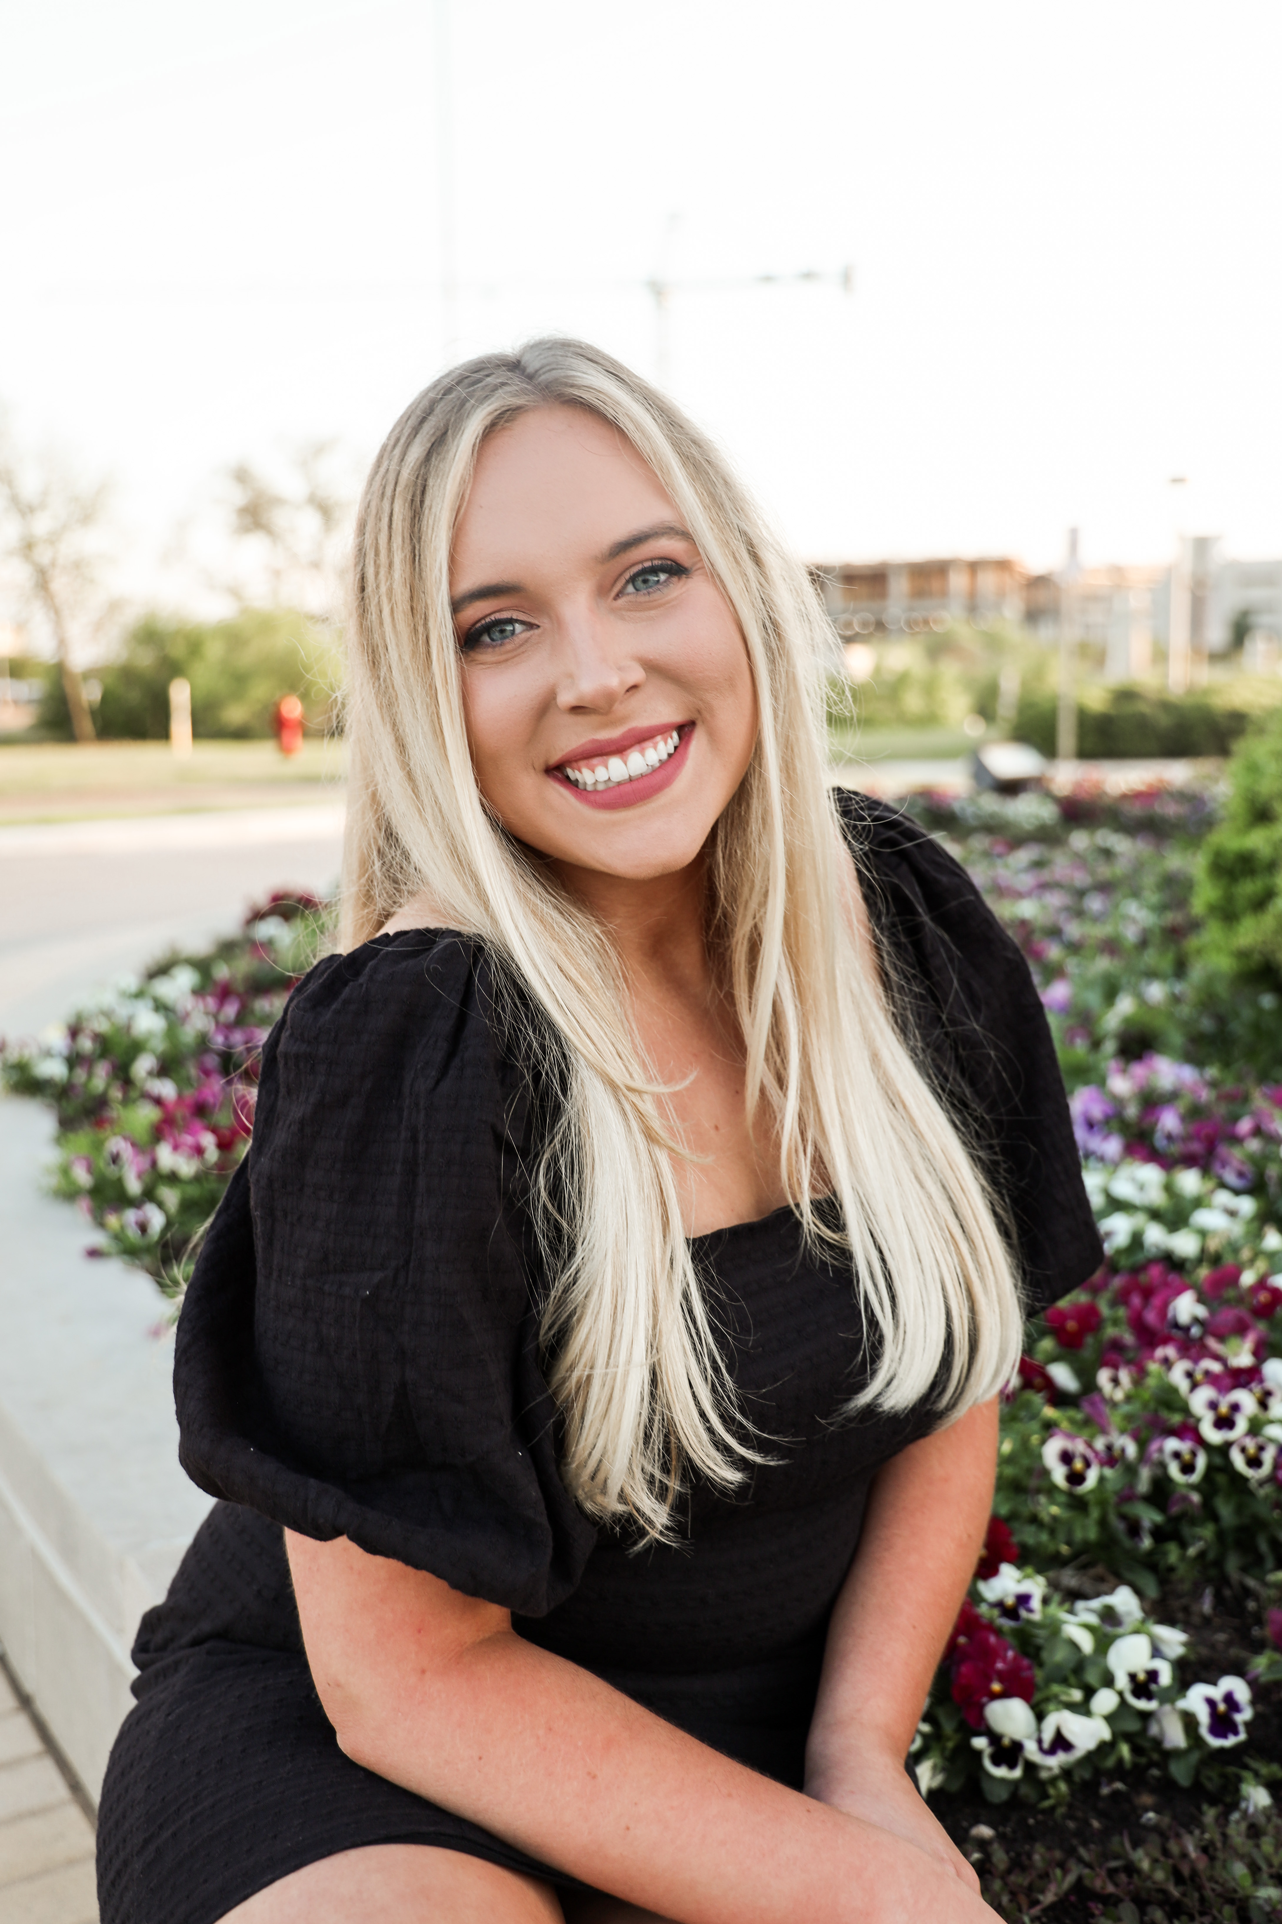

Kathryn Wallace: I’m an MPH student in Occupational Safety and Health. After graduation I am looking forward to becoming an Environmental Health and Safety Specialist. When I get home from class and work, I am greeted by two adorable miniature dachshunds. I love to spend my weekends relaxing and fishing with my fiancé out by our pond.
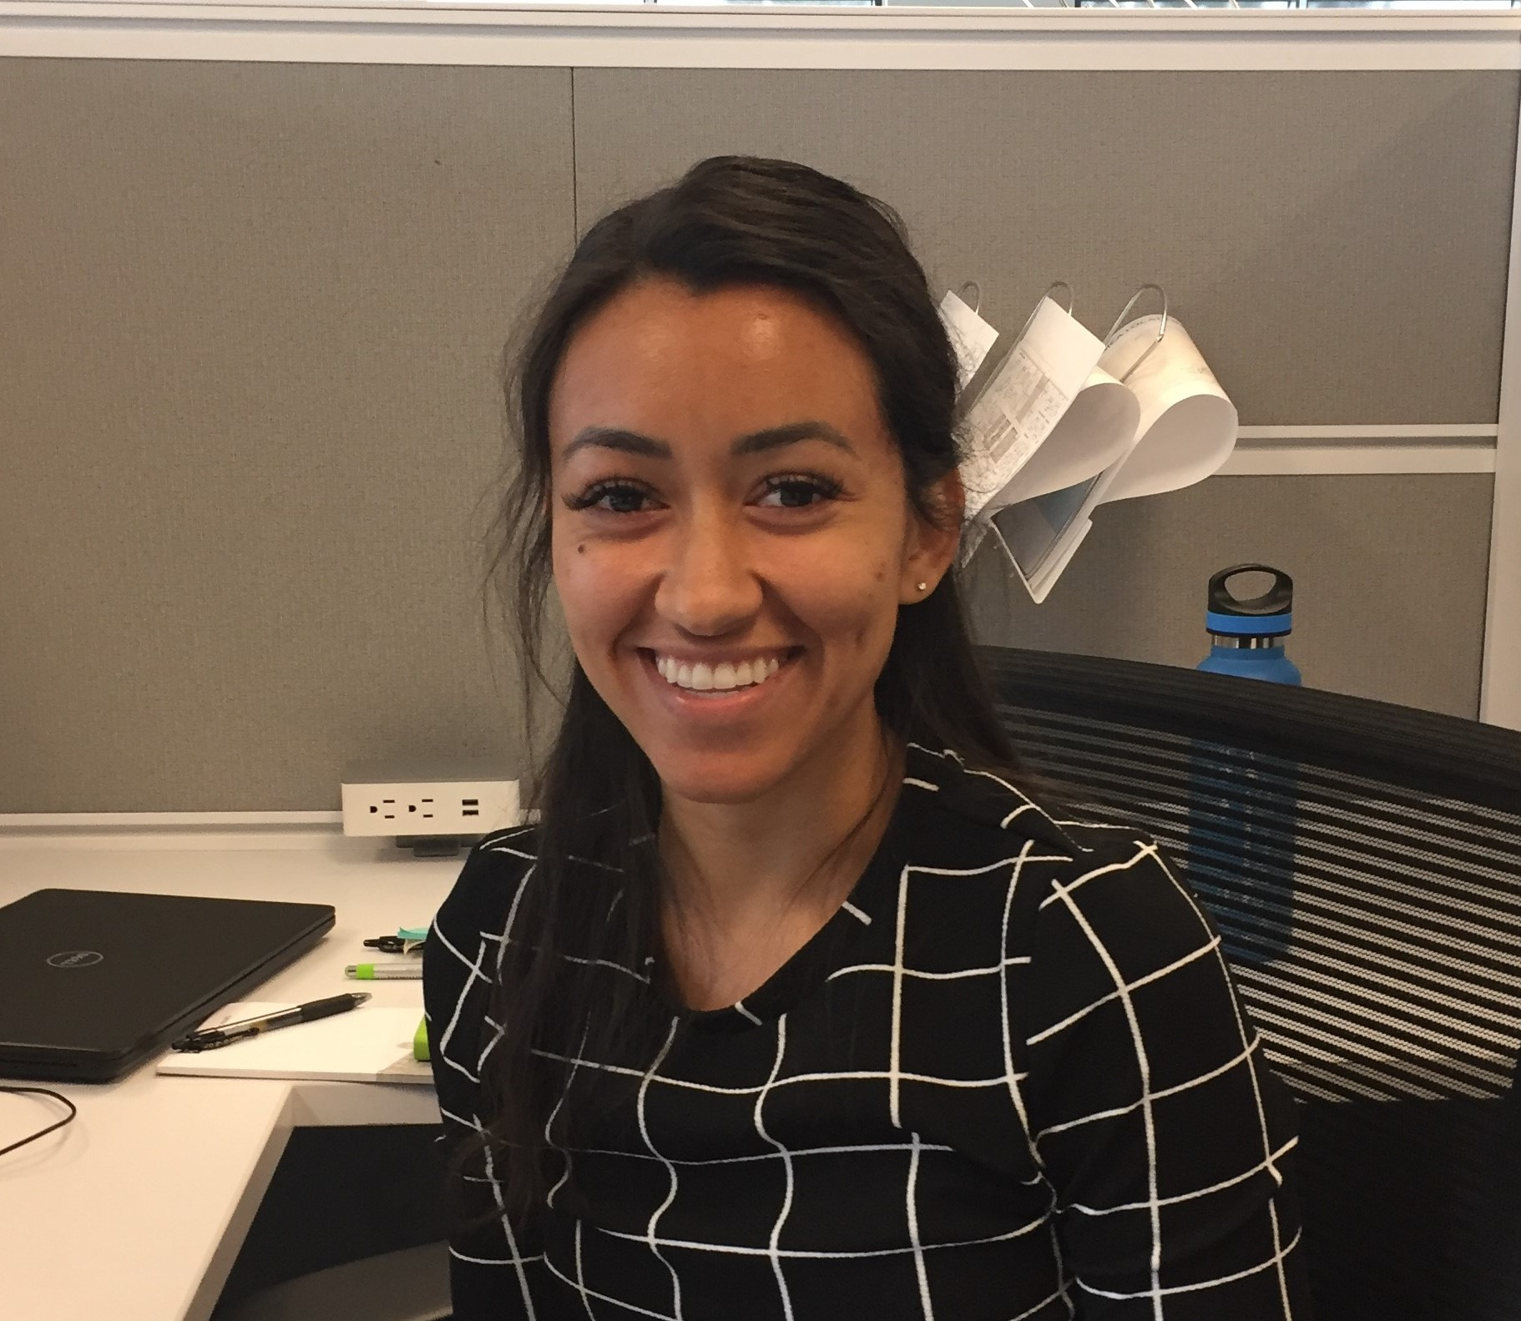

Lauren Williams: I am a DrPH student in Public Health Sciences with a concentration in Environmental Health. After graduation, I want to begin in the Environmental Health and Safety field as an EHS Specialist and work my way up towards an Industrial Hygienist position. My hometown is the Old East Dallas area, but I moved from Sunnyvale, Texas, to College Station. I have had the chance to travel to beautiful places such as California, New York, Oklahoma, Spain, Turkey, Mexico, Greece, and the islands of Greece (my favorite island being Mykonos). My family of 5 includes my mom, my dad, my younger brother, my younger sister, and me. We have owned an eclectic mix of pets like fish, 3 dogs; 3 guinea pigs (one of which is still alive), 2 hermit crabs, and 1 alligator. My hobbies include cooking, cross-stitching, soccer, reading, dancing, traveling, gardening produce, video games, and yoga.

